ATAC-Seq Protocol

Overall:
1) Prepare nuclei from fresh tissue or frozen tissue.
2) Follow attached Buenrostro et al protocol for transposition and library preparation.
3) Clean-up libraries w Qiagen PCR kit or AMPure beads. We used Qiagen Minelute.
4) QC and quantify libraries.
5) Sequence 50PE at 20-40M pairs ends.

Nuclei preparation:

Fresh tissue:

Dissect appropriate amount of tissue. You need 50K cells for each ATAC-seq reaction. Optimize enzymatic dissociation for the tissue of interest. We use papain (Worthington) for fetal brain and trypsin for cultured lines. Make sure dissociated cells are healthy and have minimal debris. Following enzymatic dissociation, quantify cell concentration and pellet 50K cells per reaction (500g 4min at 4C); proceed to Buenrostro protocol starting from: Cell Preparation, Step 3.

AMPure
- Cleanup the final PCR reaction with 1.8X volume Ampure XP beads (pre-warmed to room temperature for at least 30 min).
  - Transfer the PCR reaction to a non-stick nuclease-free 1.5ml tube.
  - Mix the beads mixture well for at least one minute before taking 1.8X vol into the PCR reaction. Mix the beads and PCR reaction well by pipetting up and down at least 20 times.
  - Incubate at room temperature for 5 minutes.
  - Bind the tube to the magnet to separate the beads.
  - Discard the cleared supernatant.
  - While on the magnet and without disturbing the beads, wash the beads with fresh 70% ethanol and incubate for 30 seconds. Repeat for a total of two washes.
  - Remove traces of all ethanol by careful vacuum aspiration.
  - Elute the beads with 32ul nuclease-free water. Mix well by pipetting at least 20 times and incubate at room temperature for 5 minutes.
  - Bind beads to the magnet and wait until supernatant is clear.
  - Remove 30ul supernatant and transfer to a new nuclease-free 1.5ml tube. This is the final ATACseq library ready to submit for QC and sequencing at the HGAC.

Tagmentation and Library preparation:

Follow attached Buenrostro protocol. In section III step 7, you may want to instead purify your libraries with Ampure XP beads.

ATACseq library QC and sequencing

Follow sections IV and V in Buenrostro protocol or alternatively run libraries on the Agilent Bioanalyzer with the Agilent DNA HS assay kit. Good libraries have a nucleosome spacing profile as outlined in Figure 2a of the Buenrostro et al Nat Methods paper. The same laddering will be observed in a gel or Bioanalyzer profile, with each peak at a ~120bp higher size (due to library adapters). If you see an undefined streak or lots of heavy bands libraries are not good. You need to repeat the transposition and/or sample prep.

Assay for Transposase Accessible Chromatin

Beijing Wu, Jason Buenrostro Greenleaf & Chang Lab Stanford University November 2013
Protocol from: Transposition of native chromatin for fast and sensitive epigenomic profiling of open chromatin, DNA-binding proteins and nucleosome position. (2013) Jason D Buenrostro, Paul G Giresi, Lisa C Zaba, Howard Y Chang & William J Greenleaf. Nature Methods. doi:10.1038/nmeth.2688

Assay for Transposase Accessible Chromatin (ATAC-seq) has been shown to be compatible with many methods for cell collection and has also worked effectively across many cell types and species. However, the following protocol has been optimized for human lymphoblastoid cells. Minor variations (i.e. cell number, centrifugation speeds, and lysis conditions) may be required to optimize for your particular application. We have seen that crosslinking greatly reduces library efficiency, and therefore we recommend starting with fresh unfixed cells.

I. Cell Preparation

1. Harvest cells (no fixation), protocol to be defined by the user.

2. Spin down 50,000 cells at 500 ×g for 5 min, 4°C.

3. Wash once with 50 µL of cold 1x PBS buffer. Spin down at 500 ×g for 5 min, 4°C.

4. Gently pipette to resuspend the cell pellet in 50 µL of cold lysis buffer (10 mM Tris-HCl, pH

7.4, 10 mM NaCl, 3 mM MgCl2, 0.1% IGEPAL CA-630). Spin down immediately at 500 ×g for 10 min, 4°C.
5. Discard the supernatant, and immediately continue to transposition reaction.

II. Transposition Reaction and Purification

1. Make sure the cell pellet is set on ice.

2. To make the transposition reaction mix, combine the following:
25 µL 2x TD Buffer (Illumina Cat #FC-121-1030)
2.5 µL Tn5 Transposes (Illumina Cat #FC-121-1030)
22.5 µL Nuclease Free H2O
50 µl Total

3. Gently pipette to resuspend nuclei in the transposition reaction mix.

4. Incubate the transposition reaction at 37°C for 30 min.

5. Immediately following transposition, purify using a Qiagen MinElute Kit.

6. Elute transposed DNA in 10 µL Elution Buffer (10mM Tris buffer, pH 8).

7. Purified DNA can be stored at -20°C.

III. PCR Amplification

1. To amplify transposed DNA fragments, combine the following in a PCR tube:

10 µL Transposed DNA
9.7 µL Nuclease Free H2O
2.5 µL 25µM Customized Nextera PCR Primer 1*
2.5 µL 25µM Customized Nextera PCR Primer 2* [Barcode]
0.3 µL 100x SYBR Green I** (Invitrogen Cat #S-7563)
25 µL NEBNext High-Fidelity 2x PCR Master Mix (New England Labs Cat #M0541)
50 µL Total

* Complete list of primers available in Section VI of this protocol

**10,000x SYBR Green I is diluted in 10mM Tris buffer, pH 8 to make a 100x working solution. 
2. Cycle as follows: (1) 72°C, 5 min
(2) 98°C, 30 sec (3) 98°C, 10 sec (4) 63°C, 30 sec (5) 72°C, 1 min
(6) Repeat steps 3-5, 4x
(7) Hold at 4°C

3. In order to reduce GC and size bias in PCR, the PCR reaction is monitored using qPCR to stop amplification prior to saturation. To run a qPCR side reaction, combine the following:

5 µL 5 cycles PCR amplified DNA
4.44 µL Nuclease Free H2O
0.25 µL 25µM Customized Nextera PCR Primer 1*
0.25 µL 25µM Customized Nextera PCR Primer 2*
0.06 µL 100x SYBR Green I
5 µL NEBNext High-Fidelity 2x PCR Master Mix
15 µL Total

* Complete list of primers available in Section VI of this protocol

4. qPCR cycle as follows: (1) 98°C, 30 sec
(2) 98°C, 10 sec
(3) 63°C, 30 sec
(4) 72°C, 1 min
(5) Repeat steps 2-4, 19x
(6) Hold at 4°C

5. The additional number of cycles needed for the remaining 45 µL PCR reaction is determined as following:

(1) Plot linear Rn vs. Cycle

(2) Set 5000 RF threshold

(3) Calculate the # of cycle that is corresponded to ¼ of maximum fluorescent intensity

Here is an example:
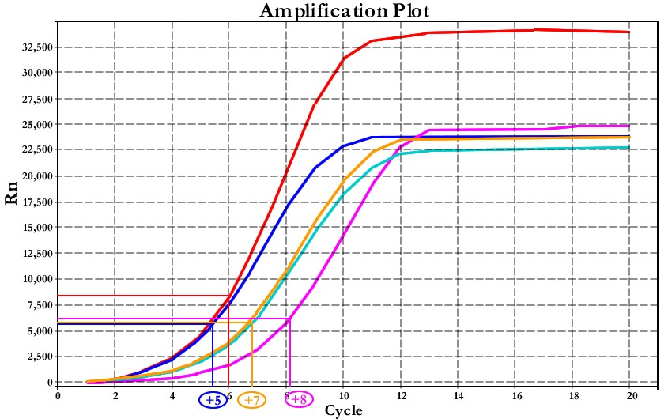

If the # of cycle to be added lies in between two cycles, the # is determined by taking the smaller integer as the # of cycle to be added (i.e., blue and pink samples)
If two samples have similar Ct values but differs in the fluorescent intensities, calculate the # of cycle using the sample with lower fluorescent intensity (i.e., red and blue samples)

6. Run the remaining 45 µL PCR reaction to the correct # of cycle. Cycle as follows:

(1) 98°C, 30 sec (2) 98°C, 10 sec (3) 63°C, 30 sec (4) 72°C, 1 min
(5) Repeat steps 2-4, x times
(6) Hold at 4°C

7. Purify amplified library using Qiagen PCR Cleanup Kit. Elute the purified library in 20 µL Elution Buffer (10mM Tris Buffer, pH 8). Be sure to dry the column before adding elution buffer.

IV. Library QC using Gel Electrophoresis

1. Dilute 1:20 100bp NEB DNA ladder with 10mM Tris Buffer, pH 8.

2. Add 0.6 µL 10x SYBR Green I to every 5 µL of diluted ladder.

3. Mix 1:1 of the diluted ladder with 2x DNA loading dye.

4. Mix 1:1 of amplified library with 2x DNA loading dye.

5. Run amplified library on 5% Bio-Rad Mini-Protean TBE Precast Gel (stored at 4°C). Load 5

µL diluted ladder/DNA loading dye mixture. Load 10 µL amplified library/DNA loading dye mixture.
6. Run at ~100 mV for 45 min.

7. SYBR Green I dye has an excitation maximum at ~488 nm and has an emission maximum at ~520 nm. DNA stained with SYBR Green I dye can be visualized using a blue-light source or imaging systems equipped with laser that emits at 488 nm. We typically use Typhoon TRIO Variable Mode Imager from Amersham Biosciences for visualization. Images are best obtained by digitizing at 100 microns pixel size resolution with a 520 nm band-pass emission filter to screen out reflected and scattered excitation light and background fluorescence.

Sample gel image:

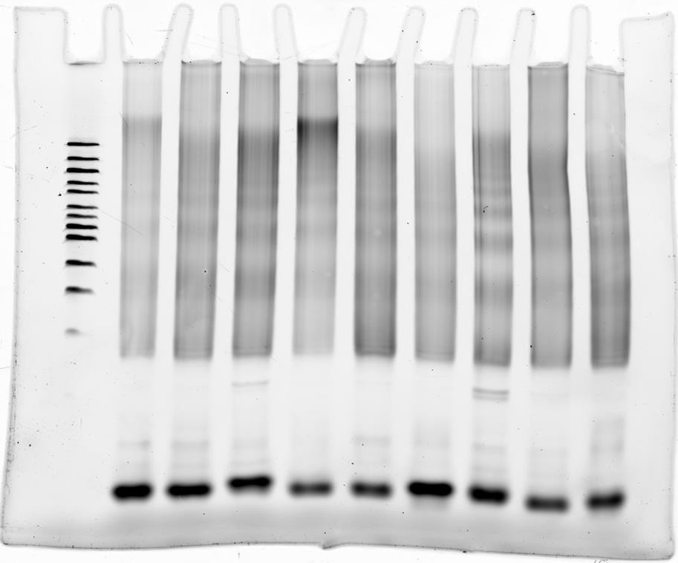
V. Library Quantitation

We use qPCR based methods to quantify our ATAC-seq libraries. We have found that other methods, such as Bioanalyzer and Qubit, can give misleading and inaccurate results due to the large distribution of insert sizes. We recommend quantifying libraries using the KAPA Library Quant Kit for Illumina Sequencing Platforms (KAPABiosystems).

VI. FAQ

1. Question: How does freezing or fixing nuclei effect data quality?

Answer: We have not explored this in great detail; however, we have seen that freezing a sample can create more noisy sequencing data. Fixing cells seems to be much more detrimental, we’ve made an attempt at this and haven’t gotten libraries we can sequence. However, its still early days for ATAC-seq, it might be possible to get this to work! Obviously if you get it to work, I’d be more than happy to learn about it!

2. Question: Does ATACing more cells improve library diversity?

Answer: Yes and No. ATAC-seq seems to be robust to variations within cell number (roughly 25k to 75k). Having too few cells creates overdigestion of the nuclei and appears to create noise, having too many cells causes underdigestion, and creates high molecular weight fragments that can’t be sequenced. That being said, adding more cells, assuming you are not under transposing, can increase library diversity (meaning less PCR duplicates).

3. Question: How do I know how many cells to add to the transposition reaction?

Answer: Assuming cells are happy, the biggest source of failure comes from variations in cell number. We see biggest differences in the requirement of the number of cells between species; however, variation exists between cell types as well. If desired, a good way to troubleshoot or improve signal-to-noise for your particular application is to do a titration of cells, and if your cheap like I am, I would scale the reaction down 10x and titrate using 5,000 cells and 5uL transposition reactions. When you find a sample that best matches the gel above, then simply scale up to the 50uL reaction.
4. Question: Does Illumina sell Transposase by itself, if so where can I get it?

Answer: Sorry, like you know, ATAC-seq is not a supported application for the Nextera kit. Perhaps in the future Illumina will offer an ATAC-seq kit!

5. Question: Did you optimize the transposition conditions for ATAC-seq?

Answer: Yes, when we first started optimizing the transposition conditions for ATAC-seq, we found that 37C and 30 minutes gave the best results. However, those were early days, and it may be possible to improve this further.

6. Question: Can you use the PCR mix and primers from the Illumina Nextera kit instead of the custom primers?
Answer: Yes, however, like other aspects of this protocol, the published PCR conditions are optimized to reduce GC/ length bias and specifically PCR artifacts from PCR primer dimers. Unfortunately we don’t have sequencing data comparing the two, these results are mostly from personal experience.

7. Question: Do the PCR primers need to be PAGE or HPLC purified?

Answer: As a general observation, it does not seem to be a requirement that library PCR

primers need to be PAGE/ HPLC purified.

8. Question: Do I need custom sequencing primers to sequence these libraries?

Answer: No, all you need to do is to tell the sequencing facility to use the standard Nextera sequencing primer.

9. Question: Do the large >1kb sizes effect cluster generation and data quality?

Answer: Not at all, in fact, they are quite useful for understanding chromatin compaction. Having such large fragments does make the library quantitation tricky, but so far, we haven’t had any issues if we use the KAPPA quantitation kit.

VII. ATAC-seq Oligo designs for PCR

Ad1_noMX | AATGATACGGCGACCACCGAGATCTACACTCGTCGGCAGCGTCAGATGTG
Ad2.1_TAAGGCGA | CAAGCAGAAGACGGCATACGAGATTCGCCTTAGTCTCGTGGGCTCGGAGATGT
Ad2.2_CGTACTAG | CAAGCAGAAGACGGCATACGAGATCTAGTACGGTCTCGTGGGCTCGGAGATGT
Ad2.3_AGGCAGAA | CAAGCAGAAGACGGCATACGAGATTTCTGCCTGTCTCGTGGGCTCGGAGATGT
Ad2.4_TCCTGAGC | CAAGCAGAAGACGGCATACGAGATGCTCAGGAGTCTCGTGGGCTCGGAGATGT
Ad2.5_GGACTCCT | CAAGCAGAAGACGGCATACGAGATAGGAGTCCGTCTCGTGGGCTCGGAGATGT
Ad2.6_TAGGCATG | CAAGCAGAAGACGGCATACGAGATCATGCCTAGTCTCGTGGGCTCGGAGATGT
Ad2.7_CTCTCTAC | CAAGCAGAAGACGGCATACGAGATGTAGAGAGGTCTCGTGGGCTCGGAGATGT
Ad2.8_CAGAGAGG | CAAGCAGAAGACGGCATACGAGATCCTCTCTGGTCTCGTGGGCTCGGAGATGT
Ad2.9_GCTACGCT | CAAGCAGAAGACGGCATACGAGATAGCGTAGCGTCTCGTGGGCTCGGAGATGT
Ad2.10_CGAGGCTG | CAAGCAGAAGACGGCATACGAGATCAGCCTCGGTCTCGTGGGCTCGGAGATGT
Ad2.11_AAGAGGCA | CAAGCAGAAGACGGCATACGAGATTGCCTCTTGTCTCGTGGGCTCGGAGATGT
Ad2.12_GTAGAGGA | CAAGCAGAAGACGGCATACGAGATTCCTCTACGTCTCGTGGGCTCGGAGATGT
Ad2.13_GTCGTGAT | CAAGCAGAAGACGGCATACGAGATATCACGACGTCTCGTGGGCTCGGAGATGT
Ad2.14_ACCACTGT | CAAGCAGAAGACGGCATACGAGATACAGTGGTGTCTCGTGGGCTCGGAGATGT
Ad2.15_TGGATCTG | CAAGCAGAAGACGGCATACGAGATCAGATCCAGTCTCGTGGGCTCGGAGATGT
Ad2.16_CCGTTTGT | CAAGCAGAAGACGGCATACGAGATACAAACGGGTCTCGTGGGCTCGGAGATGT
Ad2.17_TGCTGGGT | CAAGCAGAAGACGGCATACGAGATACCCAGCAGTCTCGTGGGCTCGGAGATGT
Ad2.18_GAGGGGTT | CAAGCAGAAGACGGCATACGAGATAACCCCTCGTCTCGTGGGCTCGGAGATGT
Ad2.19_AGGTTGGG | CAAGCAGAAGACGGCATACGAGATCCCAACCTGTCTCGTGGGCTCGGAGATGT
Ad2.20_GTGTGGTG | CAAGCAGAAGACGGCATACGAGATCACCACACGTCTCGTGGGCTCGGAGATGT
Ad2.21_TGGGTTTC | CAAGCAGAAGACGGCATACGAGATGAAACCCAGTCTCGTGGGCTCGGAGATGT
Ad2.22_TGGTCACA | CAAGCAGAAGACGGCATACGAGATTGTGACCAGTCTCGTGGGCTCGGAGATGT
Ad2.23_TTGACCCT | CAAGCAGAAGACGGCATACGAGATAGGGTCAAGTCTCGTGGGCTCGGAGATGT
Ad2.24_CCACTCCT | CAAGCAGAAGACGGCATACGAGATAGGAGTGGGTCTCGTGGGCTCGGAGATGT

